Week 2 Lab: SQL Server Authentication
Before starting this lab, the most important thing I wish I had known is that SQL Server defaults to Windows Authentication only during installation, so creating a SQL Server login will fail silently unless mixed mode authentication is enabled first through Server Properties. That configuration step also requires a full service restart before SQL Server Authentication actually becomes available, which the lab instructions do not make explicit. I ran into this after creating the testuser login and attempting to connect with it, only to find the connection refused until I restarted the SQL Server service and reconnected.
The second thing worth knowing upfront is that the two login types in this lab operate at completely different layers. The Windows Authentication login (DU\Grace.Luhanga) inherits its identity from the operating system, confirmed first by running net user and whoami in PowerShell (Figures 1 and 2). The SQL Server login (testuser) is managed entirely within SQL Server itself and has no tie to the OS. Reviewing the Server Roles page for each login made this concrete: my Windows account carried sysadmin privileges by default because it installed the instance, while testuser was assigned the public role only. That difference illustrates the least-privilege principle directly, since a new SQL login starts with minimal access unless explicitly granted more. This lab connected the AAA framework to hands-on configuration in a way that made the concepts easier to retain.
Screenshots

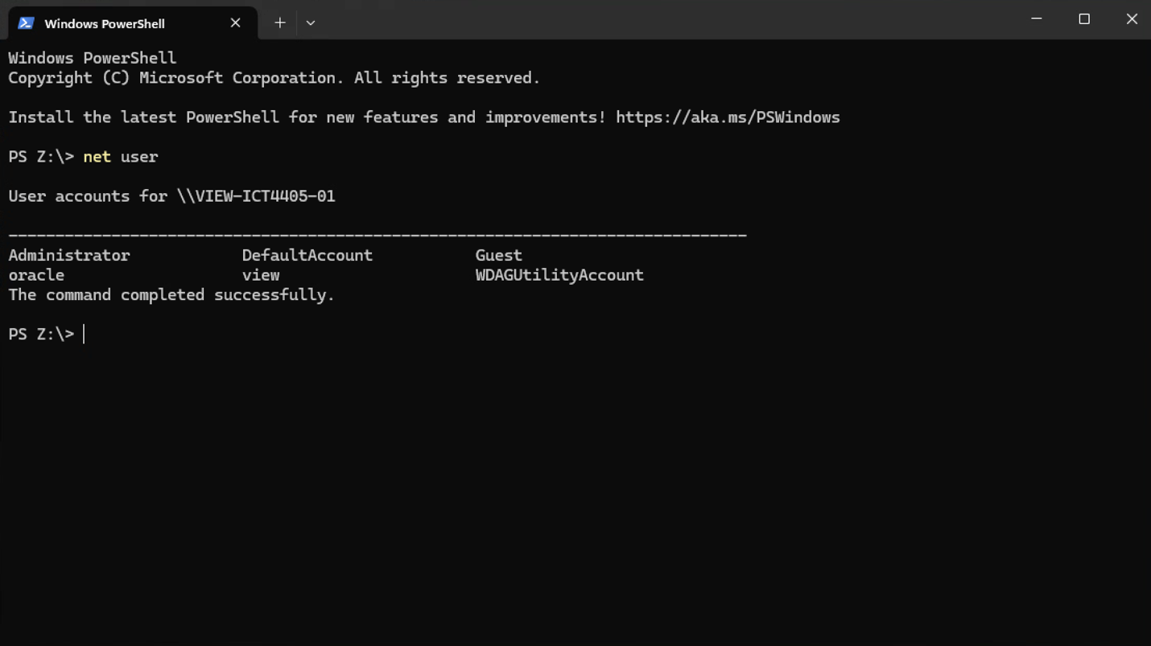

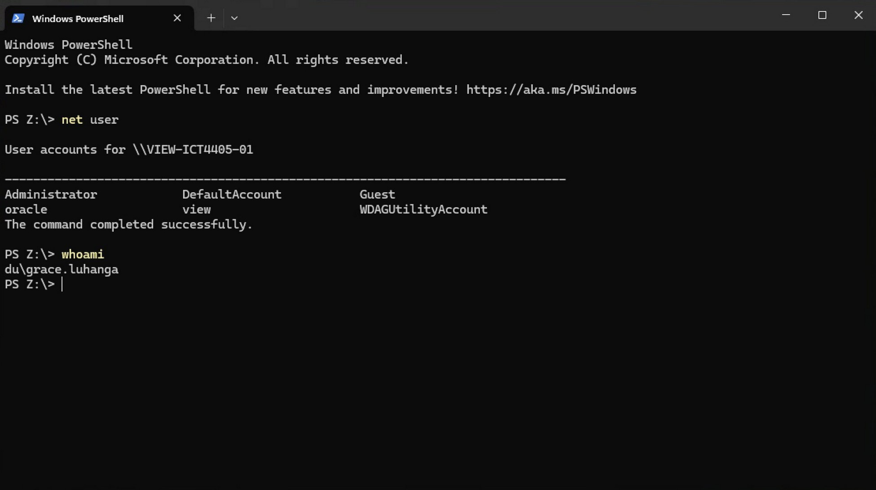
Figure 1: Listing OS user accounts on the Horizon VM using net user in PowerShell
Figure 2: Confirming active session identity with whoami – logged in as DU\Grace.Luhanga
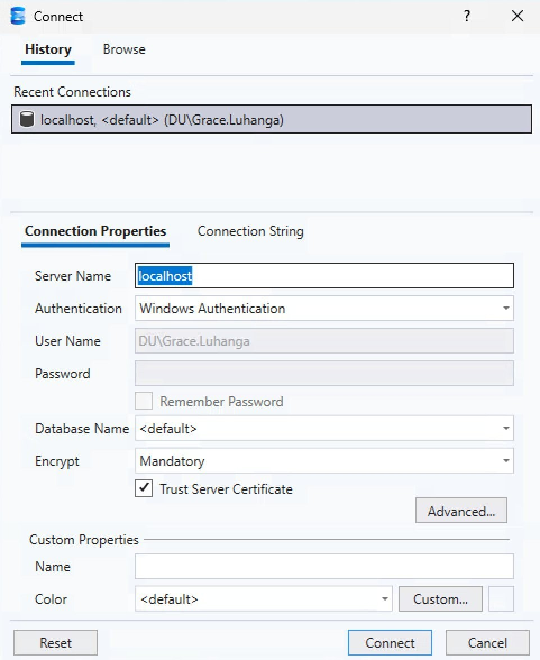
Figure 3: SSMS connection dialog – Windows Authentication selected for DU\Grace.Luhanga

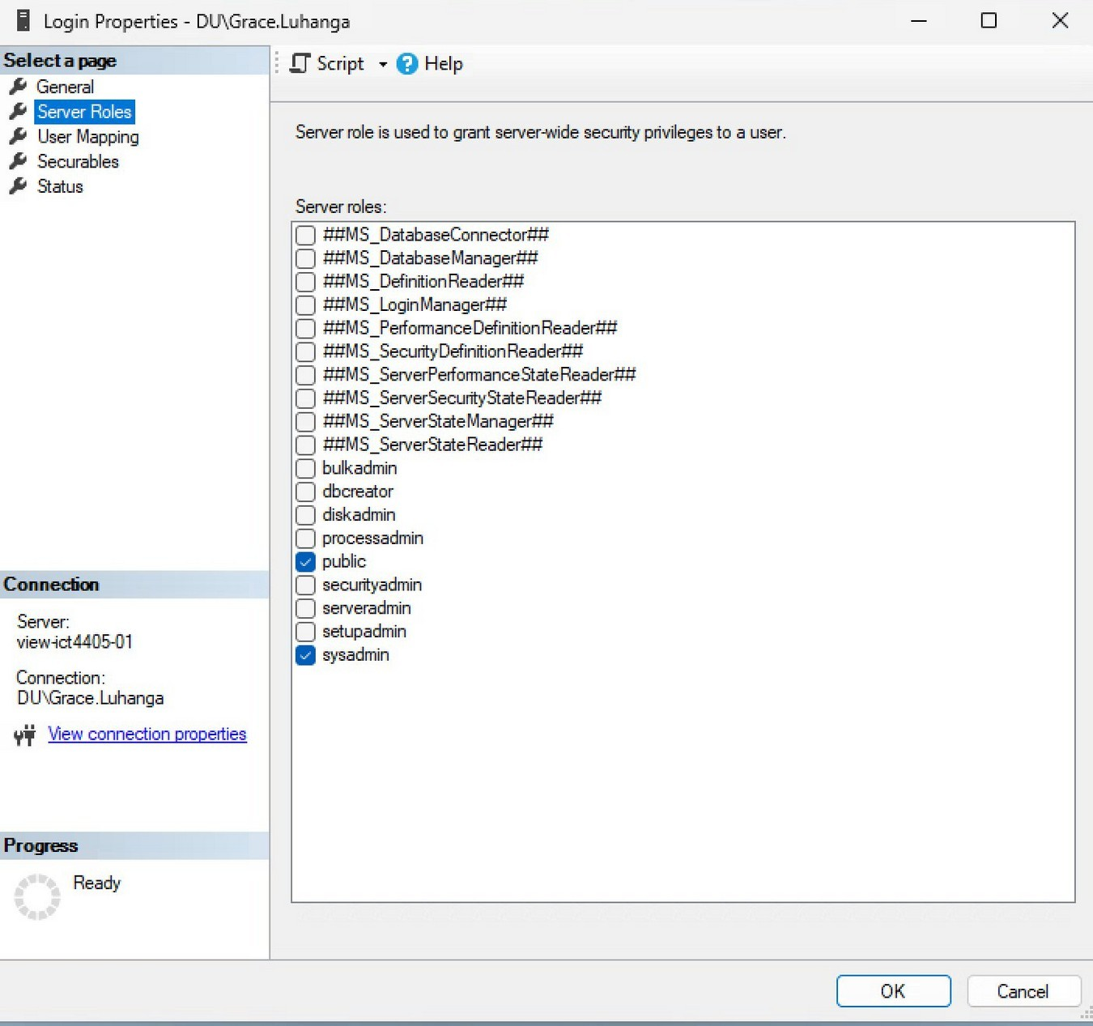
Figure 4: Login Properties for DU\Grace.Luhanga – public and sysadmin server roles assigned
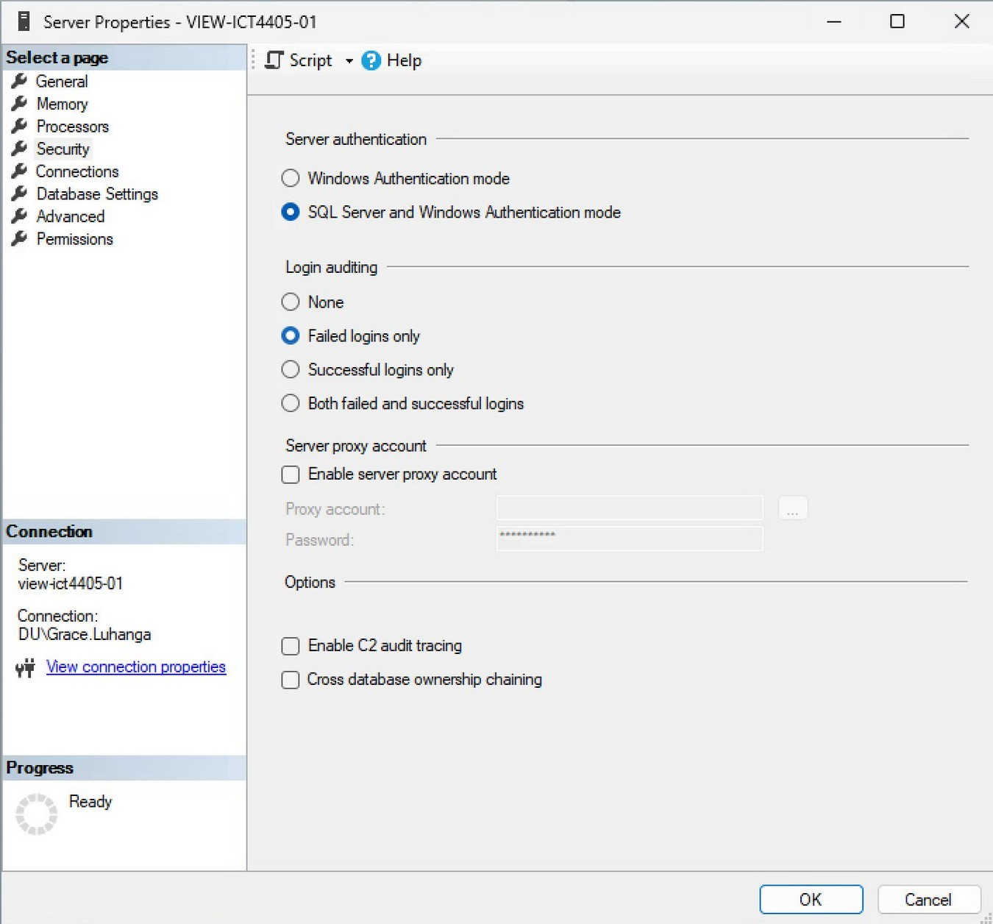

Figure 5: Server Properties Security page – SQL Server and Windows Authentication mode enabled
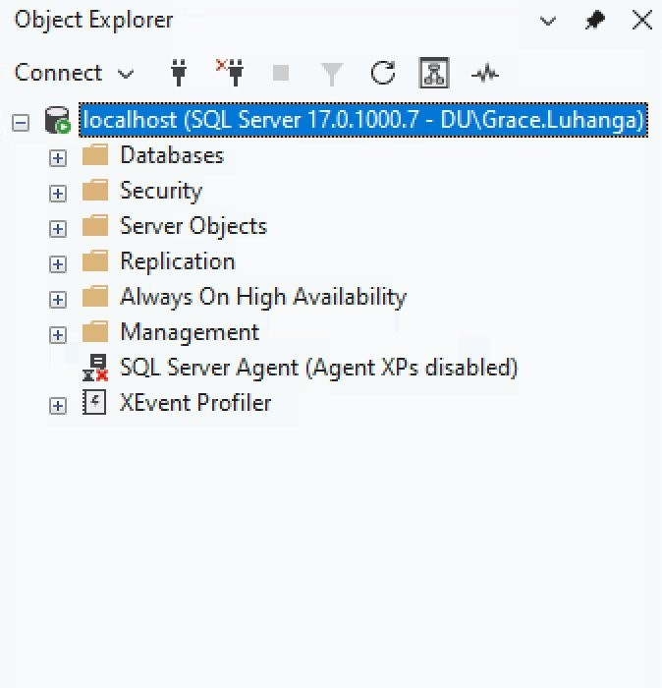
Figure 6: SSMS Object Explorer after SQL Server service restart
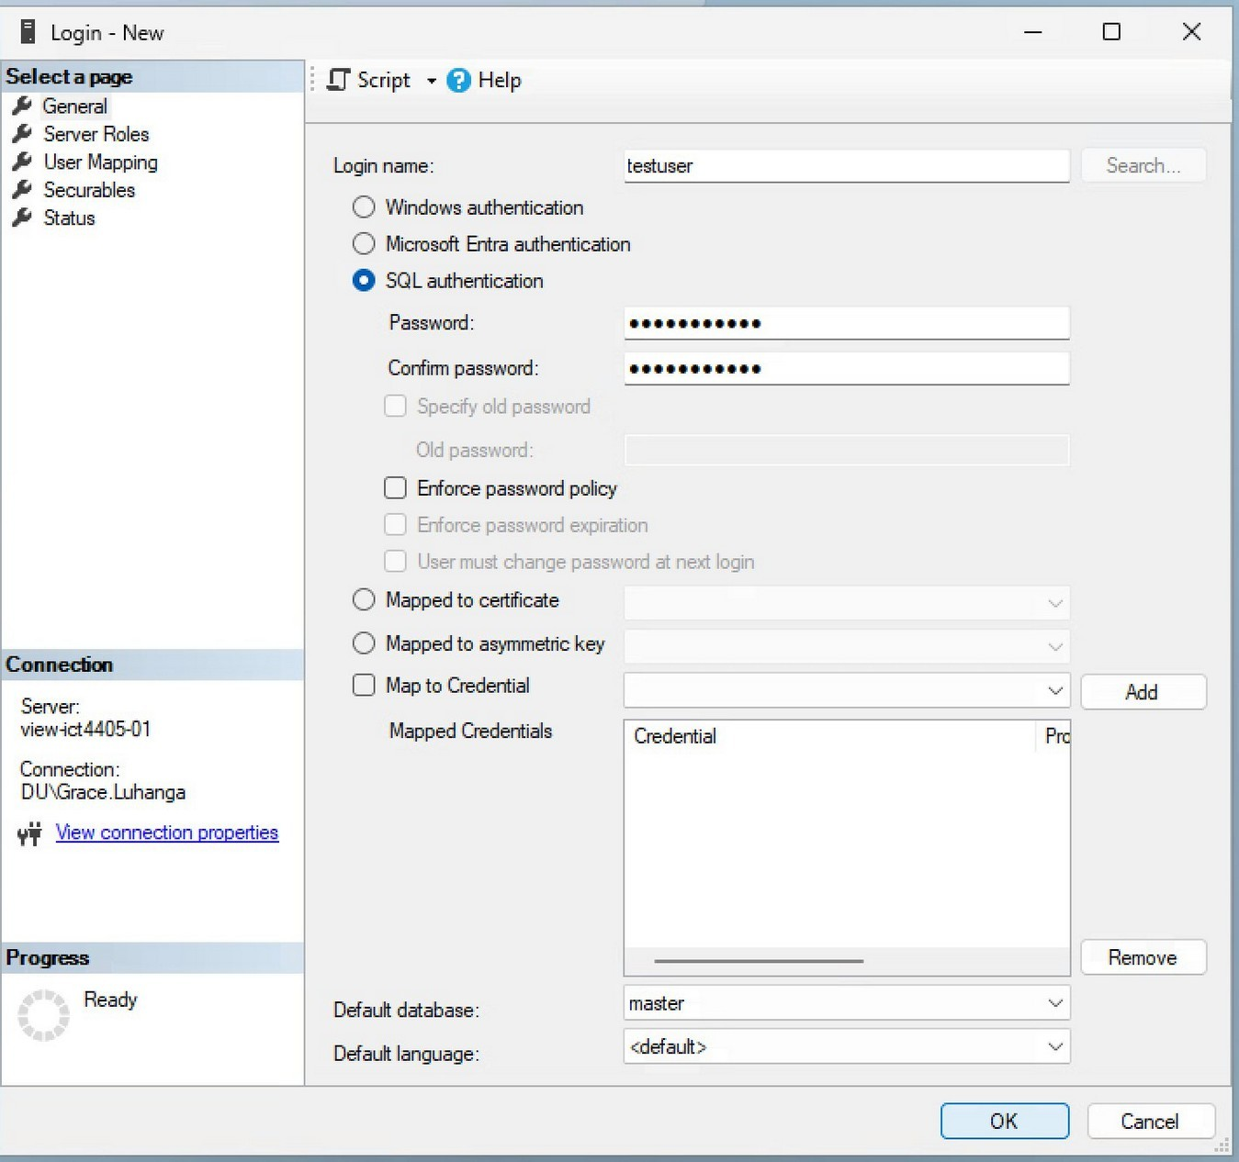
Figure 7: New Login dialog – testuser created with SQL Server Authentication

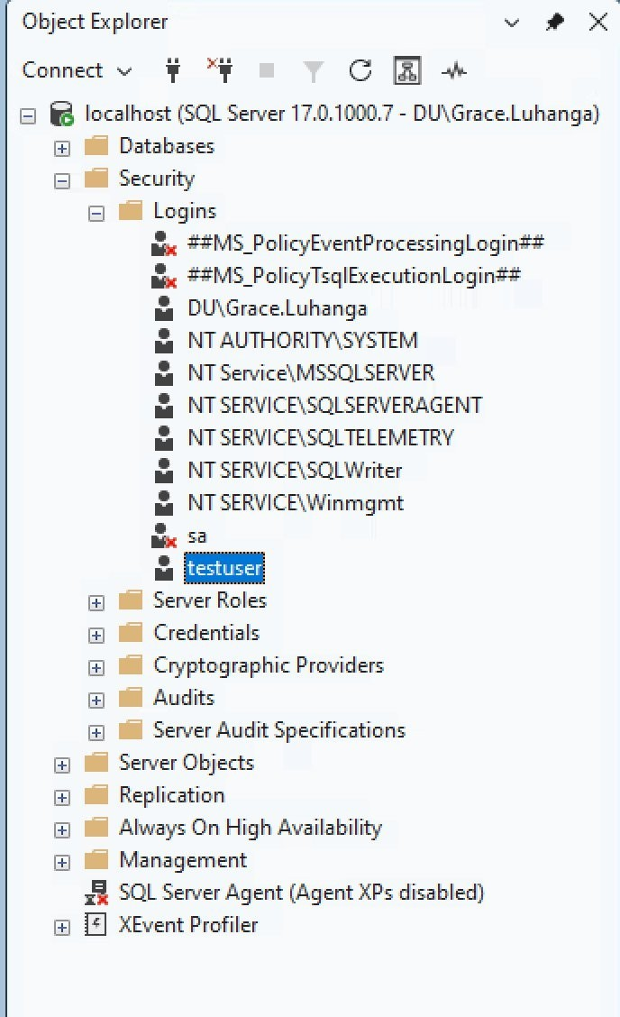
Figure 8: Object Explorer Security – Logins showing testuser alongside system accounts

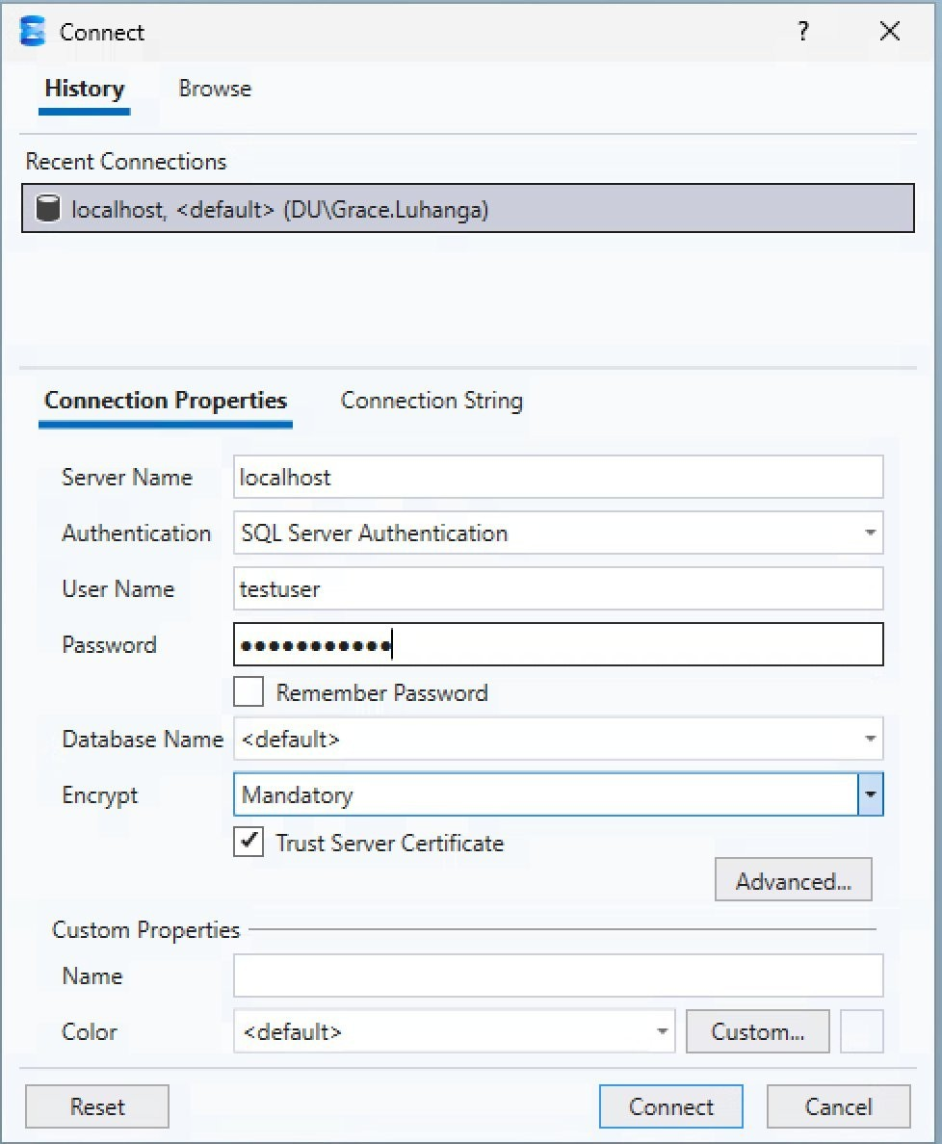
Figure 9: SSMS connection dialog using SQL Server Authentication with testuser credentials

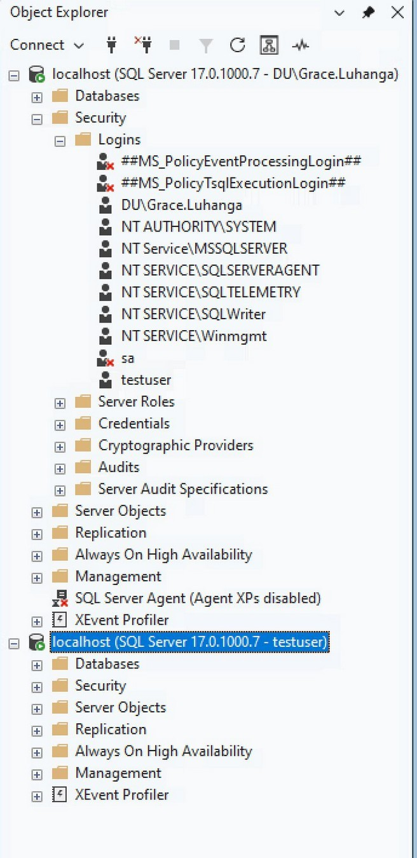
Figure 10: Object Explorer showing two simultaneous connections – DU\Grace.Luhanga and testuser

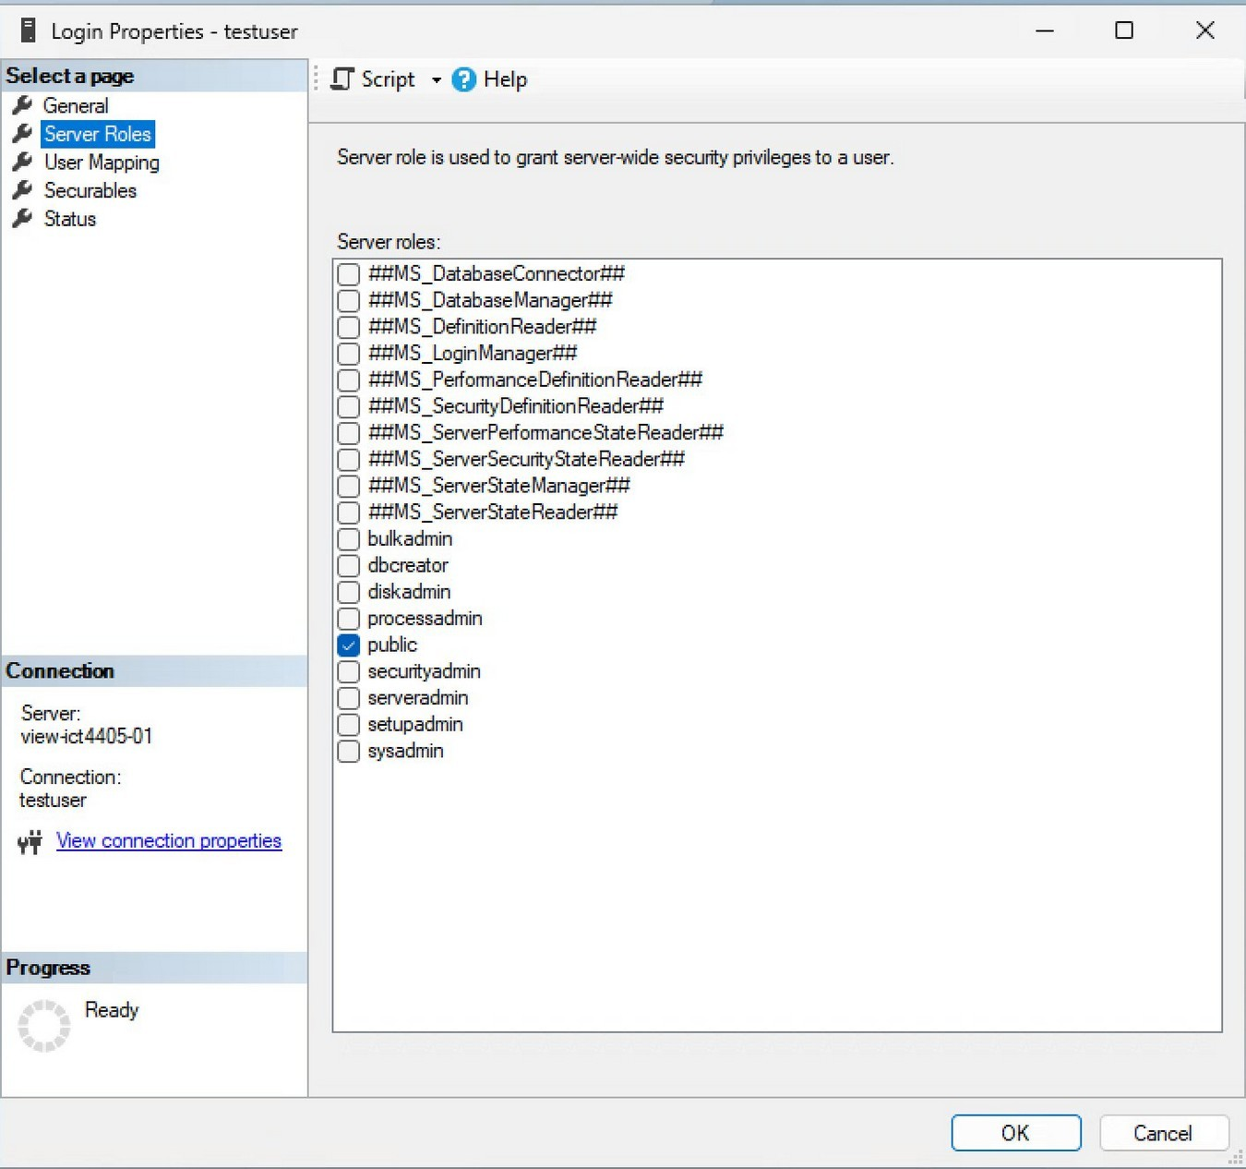
Figure 11: Login Properties for testuser – public role only, confirming least-privilege baseline

